* What is single sign on(sso) | How SSO works with saml

Youtube Video Link: <https://www.youtube.com/watch?v=cD6pkL020q4>

Real time scenario – Suppose, you are attending one of the big fat indian wedding and it’s multibillionaire wedding. so, security is very tight and in the entrance, you need to show your personal identity card and when you enter into the campus where multiple foods stall is there and you need to show your identity and wedding invitation card in every place. Its very inconvenience for you to show your identity and wedding invitation card in every stall and its ruins your enjoyment. For this problem, it’s better to show your identity card and wedding invitation on entrance then security guard gives you a band which you can wear and it’s validate that your identity is verified on entrance and it’s make thing easier for you to enjoy the foods in campus.

So, it’s called single sign on and it’s like your identity is authenticated or authorized on entrance at the architect and now, you can go and do your work easily. SSO uses SAML(Security Assertion Markup language) . SAML is open standard to exchange identity between an identity provider and service provider.

There are three parties involves in SSO process:

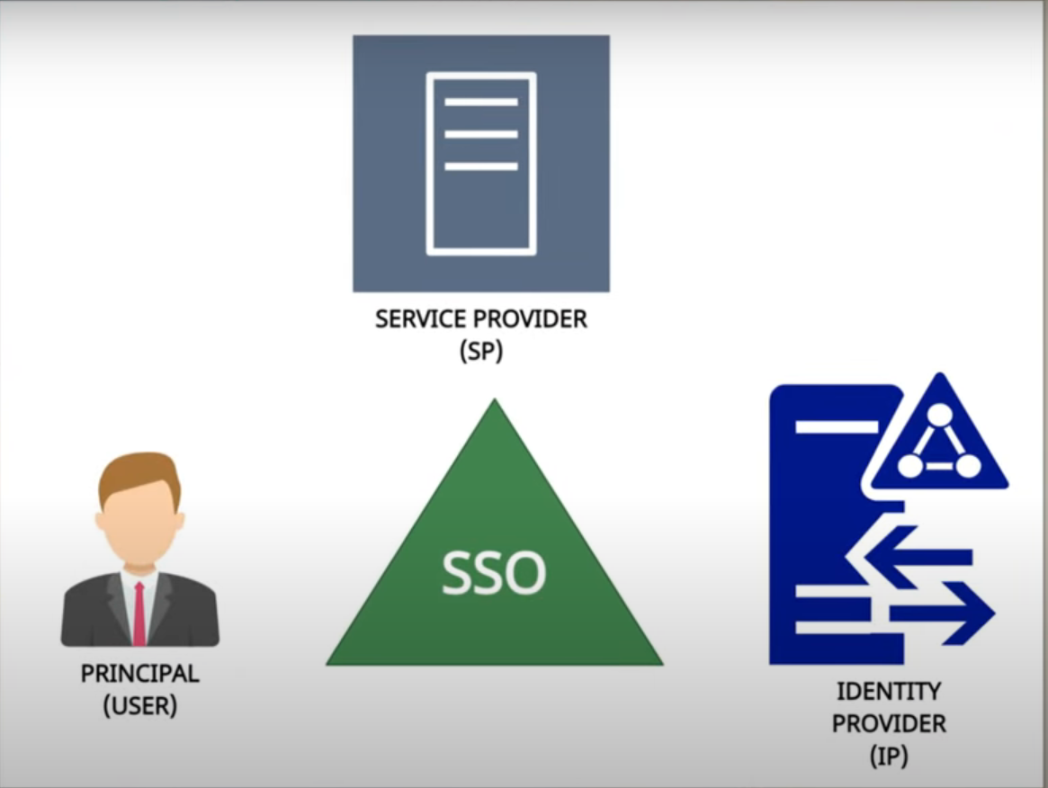

1. User: who request for service
2. Service Provider: who is giving the service
3. Identity Provider: who is identify the user identity that is that user legitimate user or not.

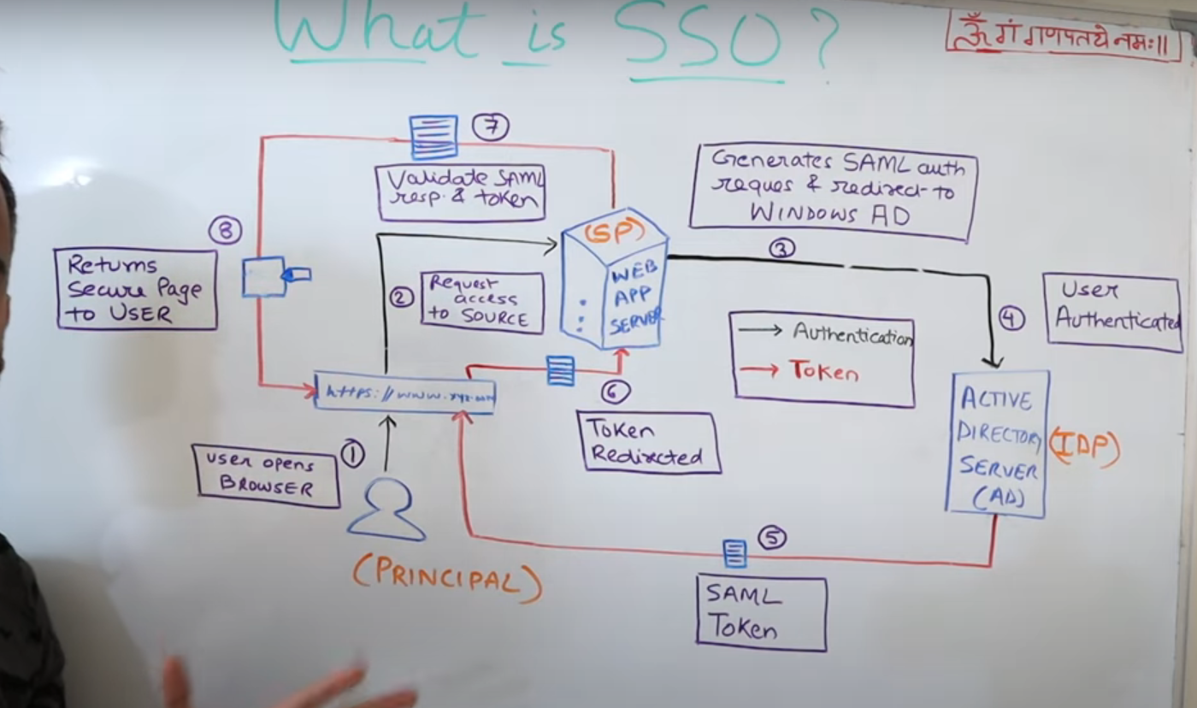

* Black arrow – it’s show the authentication workflow
* Red arrow – it shows the token workflow.

Step – 1: User opens up the browser and enters the URL of particular service provider.

Step – 2: Request access to source

Step – 3: Generate SAML Request & Redirect to windows Active Directory

Step – 4: when User is authenticated from active directory

Step – 5: it’s generating SAML Token when user authenticated. SAML token stores the user information in form of XML.

Step – 6: Browser redirects token to Service Provider

Step – 7: Service provider validates SAML response and if it’s valid token

Step – 8: Service provider access to web page

Note: SAML token has some kind of duration. So, in the period of time you can able to login silently into the system.

Note: User once logs into the network & then authentication for apps happens silently(until token’s validity)